**Advanced Algorithms**

**Exercise for Lecture 13**

|  |  |  |  |
| --- | --- | --- | --- |
| **Student Name** |  | **Student ID** |  |
| **Problem 1** |  | | |
| **Problem 2** |  | | |
| **Problem 3** |  | | |
| **Total Score** |  | | |
| **Notes** | Deadline: **2023-11-14 24:00**  Submission Format: ‘**Lecture13_Name_Student ID.docx**’, and please send to: **[1914499454@qq.com](mailto:algorithms_23fall@163.com)**.  This assignment is meant to be an evaluation of your **individual** understanding coming into the course and should be completed **without collaboration** or outside help. | | |

1、To solve the following linear programming problem using the simplex method.

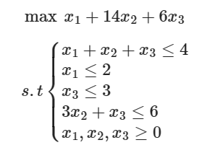

2、Solve the following linear program using SIMPLEX:

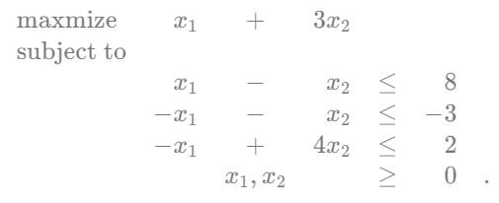

3、In this scenario, you have a machine with three different processes, A, B, and C. The machine can switch between these processes to produce products. Process A can produce 2 tons of product X and 20 tons of product Y per hour, process B can produce 7.5 tons of product X and 5 tons of product Y per hour, and process C can produce 3 tons of product X and 10 tons of product Y per hour. Your goal is to produce a minimum of 10,000 tons of product X and 30,000 tons of product Y using only one machine. You want to determine the minimum amount of time the machine needs to work to meet these production requirements.